Streamlit Interface Development Report
1. Introduction
This practical exercise involved developing a simple interactive web interface using Python and Streamlit. The purpose was to practise the use of Streamlit layout components and widgets to create an organised and interactive application. The interface consists of a sidebar for selecting a model and adjusting a temperature value, together with a main area containing separate sections for Draft and Final text.
2. Objectives
The objectives of the exercise were to:
- Create a sidebar containing interactive widgets.
- Add a model selection box and temperature slider.
- Divide the main page into two columns.
- Create Draft and Final text areas.
- Add a Debug Info section to display the current widget values.
3. Tools Used
The application was developed using Python and the Streamlit library. Streamlit was imported using import streamlit as st.
4. Implementation
The sidebar was created using st.sidebar. It contains a model selection box with three options: GPT-2, Claude, and Gemini. A temperature slider was also added with a range from 0 to 100 and an initial value of 20. The selected values are stored in the model and slider variables.
The main interface was divided into two equal columns using st.columns(2). The first column contains the Draft section and a text area where draft content can be entered. The second column contains the Final section and another text area for the final content. Both text areas have a height of 200 pixels.
A Debug Info expandable section was added below the two columns. When expanded, it displays the currently selected model and temperature value. This allows the user to confirm the values selected through the sidebar.
5. Results
The completed application produces an interactive Streamlit page matching the requirements of the exercise. The sidebar provides controls for the model and temperature, while the main area presents the Draft and Final sections side by side. The Debug Info section provides additional information about the current settings.
Figure 1: 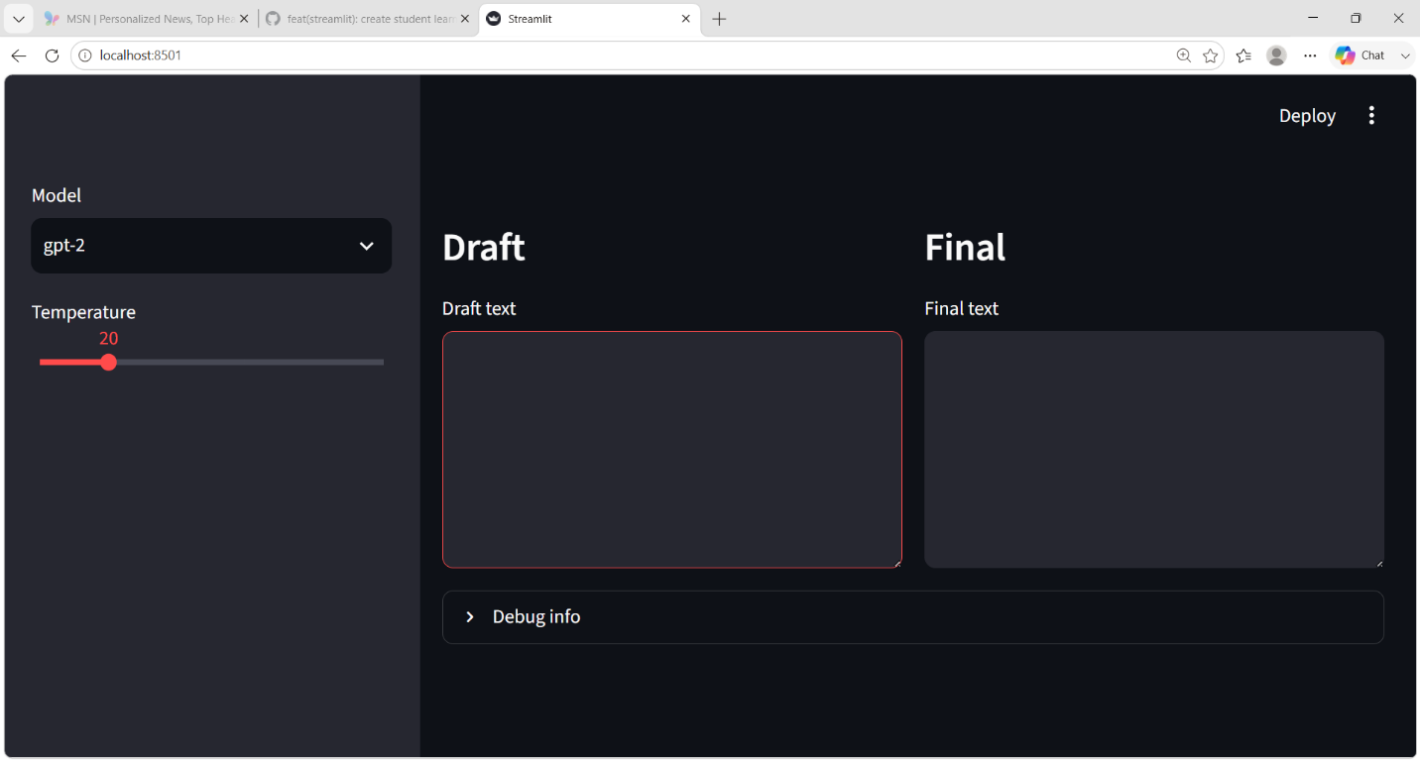
The implementation demonstrates how Streamlit can be used to create an interactive interface without requiring a separate HTML or JavaScript front end.

